PREMIUM CALCULATION ENGINE USER STORY
- Description
As a Policyholder/Customer
I want the system to automatically calculate the insurance premium using actuarial pricing models based on policy and customer risk attributes
So that accurate premium amounts can be generated for policy proposals and reduce manual calculations.

2. Inputs Required for Premium Calculation
Input Field | Description
Age | Age of the insured person
Gender | Male / Female / Other
Smoking Status | Smoker / Non-Smoker
Sum Assured | Total coverage amount
Policy Term | Duration of the policy in years

3. Acceptance Criteria
ID | Description
AC-01 | System shall accept policyholder details (Age, Gender, Smoking Status, Sum Assured, Policy Term).
AC-02 | System shall validate that all mandatory fields are entered before premium calculation.
AC-03 | System shall apply actuarial pricing formulas based on risk attributes.
AC-04 | If Smoking Status = Frequent Smoker, risk loading of 30% shall be applied to the premium.
AC-05 | Premium shall increase with higher Sum Assured values & Age>50.
AC-06 | Premium shall vary depending on Policy Term selected.
AC-07 | System shall display calculated premium instantly after inputs are entered.
AC-08 | If any input is invalid (e.g., Age outside allowed range), system shall display an error message.

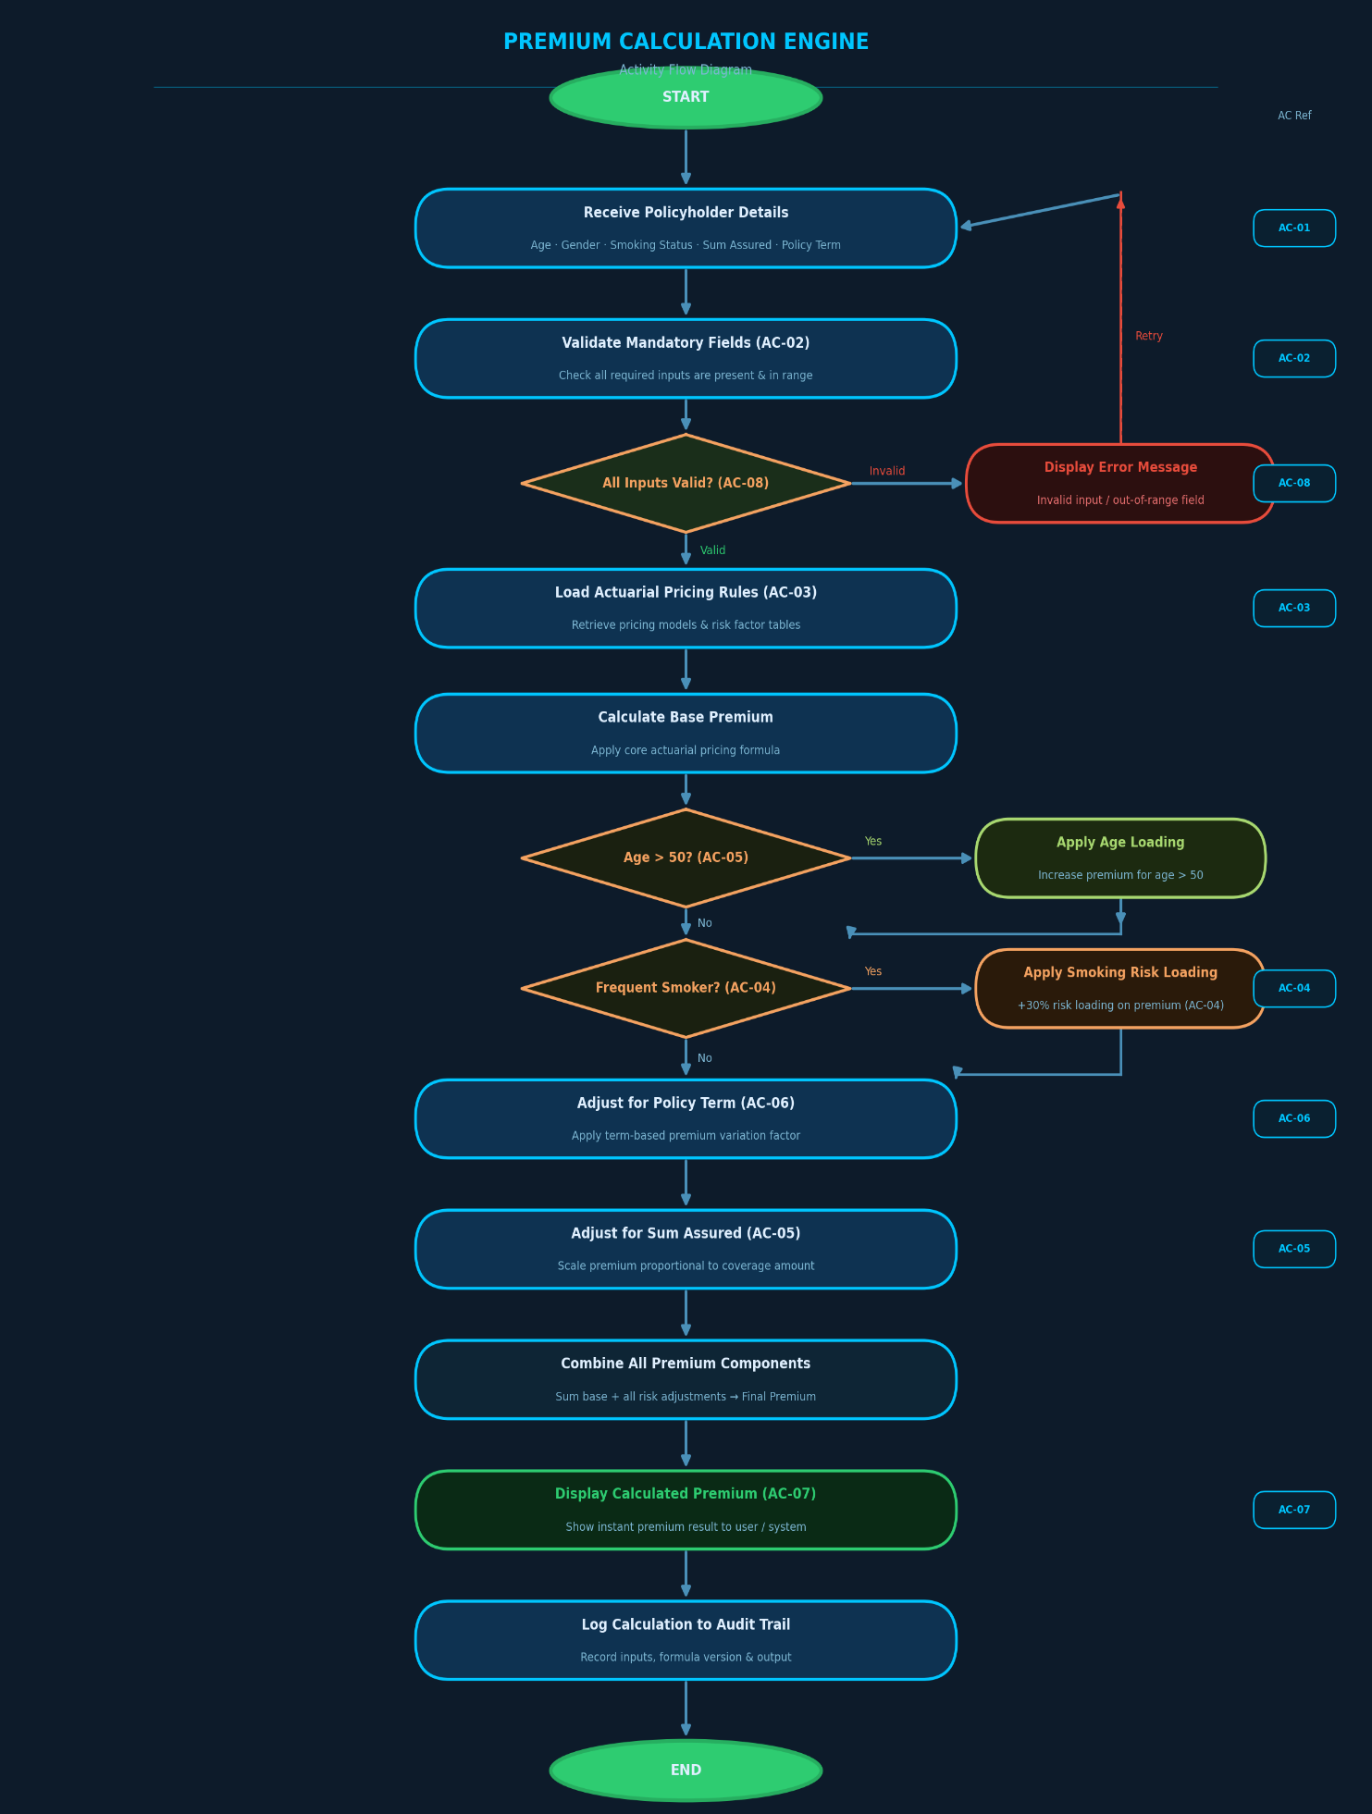
4. Activity Flow Diagram
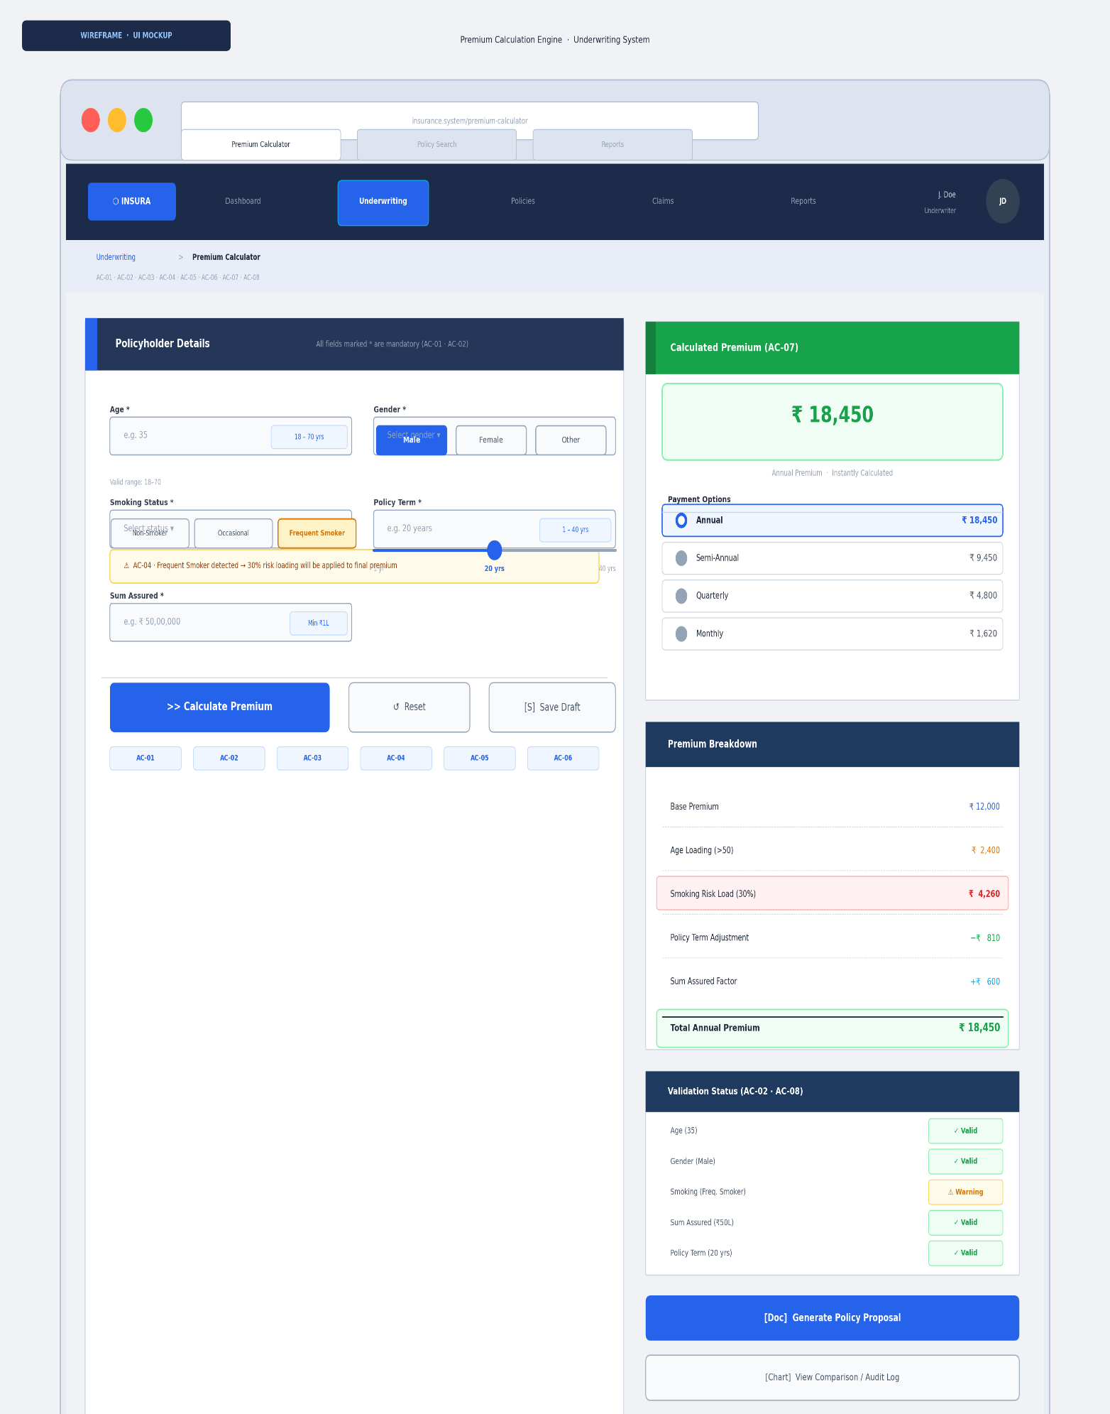
5. Wireframe – Premium Calculation Screen

